UNIVERSITY INSTITUTE OF COMPUTING

PROJECT REPORT
ON
Gym Management System

Program Name: BCA(Hons)(Data Science)
Subject Name/Code: Database Management System
(25CAP-204)

Submitted by: Submitted to:
Name: Sumit Chauhan Name: Mrs. Harkamal Kaur
UID: 25BCD10093 Designation: Assistant Professor
Section: 25BCD-2(A)

Project Report: Gym Management System
1. Introduction:-
The Gym Management System is a database project designed to manage the daily activities of a gym. It stores information about gym members, trainers, membership plans, attendance records, and payments.
The project uses Oracle SQL to create and manage database tables. It helps maintain records systematically, reduces manual work, and makes it easier to retrieve information through SQL queries.
This system demonstrates important DBMS concepts such as primary keys, foreign keys, table relationships, joins, and aggregate functions.

2. Objectives / Problem Statement:-
Problem Statement
Managing gym records manually can be time-consuming and may cause errors, duplicate records, missing payment information, and difficulties in tracking attendance and membership status.
The Gym Management System solves these problems by storing gym-related information in a structured relational database.
Objectives
- To maintain records of gym members and trainers.
- To store membership plans, fees, and durations.
- To maintain membership start dates, end dates, and status.
- To record member attendance.
- To store payment amounts and payment methods.
- To connect related tables using primary keys and foreign keys.
- To retrieve useful information through SQL queries.
- To calculate total payment collection and trainer-wise member counts.

3. Modules and Tools and Technologies Used:-
3.1 Modules
1. Plan Management Module
Stores gym membership plans, including plan ID, plan name, duration, and fees.
2. Trainer Management Module
Maintains trainer details such as trainer ID, trainer name, and specialisation.
3. Member Management Module
Stores member ID, name, age, phone number, and assigned trainer.
4. Membership Management Module
Maintains membership details, including member ID, selected plan, start date, end date, and status.
5. Attendance Management Module
Records member visits and attendance dates.
6. Payment Management Module
Stores payment IDs, membership IDs, payment amounts, and payment methods such as UPI, cash, and card.
7. Report Generation Module
Uses SQL queries to display member records, membership details, payment collections, and trainer-wise member counts.
3.2 Tools and Technologies Used
Tool / Technology | Purpose
Oracle Database | Stores and manages data
Oracle SQL | Creates tables, inserts data, and retrieves records
Online Oracle SQL editor | Executes SQL commands and displays output
Microsoft Word | Prepares the project report
GitHub | Stores and shares the project source code
3.3 Database Table Design
Your project contains six tables.
Table name | Primary key | Foreign key
PLANS | PLAN_ID | None
TRAINERS | TRAINER_ID | None
MEMBERS | MEMBER_ID | TRAINER_ID
MEMBERSHIPS | MEMBERSHIP_ID | MEMBER_ID, PLAN_ID
ATTENDANCE | ATTENDANCE_ID | MEMBER_ID
PAYMENTS | PAYMENT_ID | MEMBERSHIP_ID
The primary keys uniquely identify records. Foreign keys connect related tables and help maintain referential integrity.

4. Code with Outputs:-
4.1 Table Creation Code
The following SQL code creates the six tables used in the Gym Management System.
CREATE TABLE PLANS (
PLAN_ID NUMBER PRIMARY KEY,
PLAN_NAME VARCHAR2(30) NOT NULL,
DURATION_DAYS NUMBER,
FEE NUMBER(8,2)
);

CREATE TABLE TRAINERS (
TRAINER_ID NUMBER PRIMARY KEY,
TRAINER_NAME VARCHAR2(50) NOT NULL,
SPECIALIZATION VARCHAR2(40)
);

CREATE TABLE MEMBERS (
MEMBER_ID NUMBER PRIMARY KEY,
MEMBER_NAME VARCHAR2(50) NOT NULL,
AGE NUMBER,
PHONE VARCHAR2(15),
TRAINER_ID NUMBER,
FOREIGN KEY (TRAINER_ID)
REFERENCES TRAINERS(TRAINER_ID)
);

CREATE TABLE MEMBERSHIPS (
MEMBERSHIP_ID NUMBER PRIMARY KEY,
MEMBER_ID NUMBER,
PLAN_ID NUMBER,
START_DATE DATE,
END_DATE DATE,
STATUS VARCHAR2(15),
FOREIGN KEY (MEMBER_ID)
REFERENCES MEMBERS(MEMBER_ID),
FOREIGN KEY (PLAN_ID)
REFERENCES PLANS(PLAN_ID)
);

CREATE TABLE ATTENDANCE (
ATTENDANCE_ID NUMBER PRIMARY KEY,
MEMBER_ID NUMBER,
VISIT_DATE DATE,
FOREIGN KEY (MEMBER_ID)
REFERENCES MEMBERS(MEMBER_ID)
);

CREATE TABLE PAYMENTS (
PAYMENT_ID NUMBER PRIMARY KEY,
MEMBERSHIP_ID NUMBER,
AMOUNT NUMBER(8,2),
PAYMENT_MODE VARCHAR2(15),
FOREIGN KEY (MEMBERSHIP_ID)
REFERENCES MEMBERSHIPS(MEMBERSHIP_ID)
);
Expected output: Each CREATE TABLE statement executes successfully and creates its respective table.
Screenshot 1: Capture the successful table creation or the list of six tables in your Oracle editor.
4.2 Sample Data Insertion
Your supplied code inserts four membership plans, three trainers, five members, five memberships, six attendance records, and five payments.
A. Insert membership plans
INSERT INTO PLANS
VALUES (1, 'Monthly', 30, 1200);

INSERT INTO PLANS
VALUES (2, 'Quarterly', 90, 3000);

INSERT INTO PLANS
VALUES (3, 'Half-Yearly', 180, 5500);

INSERT INTO PLANS
VALUES (4, 'Yearly', 365, 10000);
B. Insert trainers
INSERT INTO TRAINERS
VALUES (101, 'Aman Sharma', 'Strength Training');

INSERT INTO TRAINERS
VALUES (102, 'Neha Verma', 'Yoga');

INSERT INTO TRAINERS
VALUES (103, 'Rohit Thakur', 'Cardio');
C. Insert members
INSERT INTO MEMBERS
VALUES (1001, 'Rahul', 22, '9876500101', 101);

INSERT INTO MEMBERS
VALUES (1002, 'Priya', 24, '9876500102', 102);

INSERT INTO MEMBERS
VALUES (1003, 'Karan', 20, '9876500103', 101);

INSERT INTO MEMBERS
VALUES (1004, 'Simran', 27, '9876500104', 103);

INSERT INTO MEMBERS
VALUES (1005, 'Arjun', 23, '9876500105', 102);
D. Insert memberships
INSERT INTO MEMBERSHIPS VALUES
(2001, 1001, 2, DATE '2026-09-01',
DATE '2026-11-29', 'ACTIVE');

INSERT INTO MEMBERSHIPS VALUES
(2002, 1002, 1, DATE '2026-09-03',
DATE '2026-10-02', 'EXPIRED');

INSERT INTO MEMBERSHIPS VALUES
(2003, 1003, 3, DATE '2026-09-05',
DATE '2027-03-04', 'ACTIVE');

INSERT INTO MEMBERSHIPS VALUES
(2004, 1004, 2, DATE '2026-09-08',
DATE '2026-12-06', 'ACTIVE');

INSERT INTO MEMBERSHIPS VALUES
(2005, 1005, 1, DATE '2026-09-10',
DATE '2026-10-09', 'EXPIRED');
E. Insert attendance records
INSERT INTO ATTENDANCE VALUES
(3001, 1001, DATE '2026-10-01');

INSERT INTO ATTENDANCE VALUES
(3002, 1002, DATE '2026-10-01');

INSERT INTO ATTENDANCE VALUES
(3003, 1001, DATE '2026-10-02');

INSERT INTO ATTENDANCE VALUES
(3004, 1003, DATE '2026-10-02');

INSERT INTO ATTENDANCE VALUES
(3005, 1004, DATE '2026-10-03');

INSERT INTO ATTENDANCE VALUES
(3006, 1005, DATE '2026-10-03');
F. Insert payment records
INSERT INTO PAYMENTS
VALUES (4001, 2001, 3000, 'UPI');

INSERT INTO PAYMENTS
VALUES (4002, 2002, 1200, 'CASH');

INSERT INTO PAYMENTS
VALUES (4003, 2003, 5500, 'CARD');

INSERT INTO PAYMENTS
VALUES (4004, 2004, 3000, 'UPI');

INSERT INTO PAYMENTS
VALUES (4005, 2005, 1200, 'CASH');
Expected output: Each insert statement reports that one row was inserted. In your online editor, COMMIT; is unnecessary if all statements are automatically committed.
4.3 SQL Queries with Expected Outputs
Query 1: Display all members
SELECT * FROM MEMBERS;
Expected output:
MEMBER_ID | MEMBER_NAME | AGE | TRAINER_ID
1001 | Rahul | 22 | 101
1002 | Priya | 24 | 102
1003 | Karan | 20 | 101
1004 | Simran | 27 | 103
1005 | Arjun | 23 | 102
The actual result also contains the PHONE column.
Screenshot 2: Output of all members.
Query 2: Display membership plans
SELECT * FROM PLANS;
Expected output:
PLAN_ID | PLAN_NAME | DURATION_DAYS | FEE
1 | Monthly | 30 | 1200
2 | Quarterly | 90 | 3000
3 | Half-Yearly | 180 | 5500
4 | Yearly | 365 | 10000
Screenshot 3: Output of membership plans.
Query 3: Display members with their trainers
SELECT M.MEMBER_NAME, T.TRAINER_NAME
FROM MEMBERS M
JOIN TRAINERS T
ON M.TRAINER_ID = T.TRAINER_ID;
Expected output:
MEMBER_NAME | TRAINER_NAME
Rahul | Aman Sharma
Priya | Neha Verma
Karan | Aman Sharma
Simran | Rohit Thakur
Arjun | Neha Verma
Screenshot 4: Output of members and trainers.
Query 4: Display active memberships
SELECT M.MEMBER_NAME, P.PLAN_NAME, MS.END_DATE
FROM MEMBERSHIPS MS
JOIN MEMBERS M
ON MS.MEMBER_ID = M.MEMBER_ID
JOIN PLANS P
ON MS.PLAN_ID = P.PLAN_ID
WHERE MS.STATUS = 'ACTIVE';
Expected output:
MEMBER_NAME | PLAN_NAME | END_DATE
Rahul | Quarterly | 29-Nov-2026
Karan | Half-Yearly | 04-Mar-2027
Simran | Quarterly | 06-Dec-2026
The displayed date format may differ in your editor.
Screenshot 5: Output of active memberships.
Query 5: Calculate total payment collection
SELECT SUM(AMOUNT) AS TOTAL_COLLECTION
FROM PAYMENTS;
Expected output:
TOTAL_COLLECTION
13900
The total collection from the five sample payment records is 13,900.
Screenshot 6: Output of total payment collection.
Query 6: Count members assigned to each trainer
SELECT T.TRAINER_NAME,
COUNT(M.MEMBER_ID) AS TOTAL_MEMBERS
FROM TRAINERS T
LEFT JOIN MEMBERS M
ON T.TRAINER_ID = M.TRAINER_ID
GROUP BY T.TRAINER_NAME;
Expected output:
TRAINER_NAME | TOTAL_MEMBERS
Aman Sharma | 2
Neha Verma | 2
Rohit Thakur | 1
Screenshot 7: Output of trainer-wise member count.
4.4 Screenshot checklist for printed report
Capture these seven screenshots from your actual Oracle SQL editor.
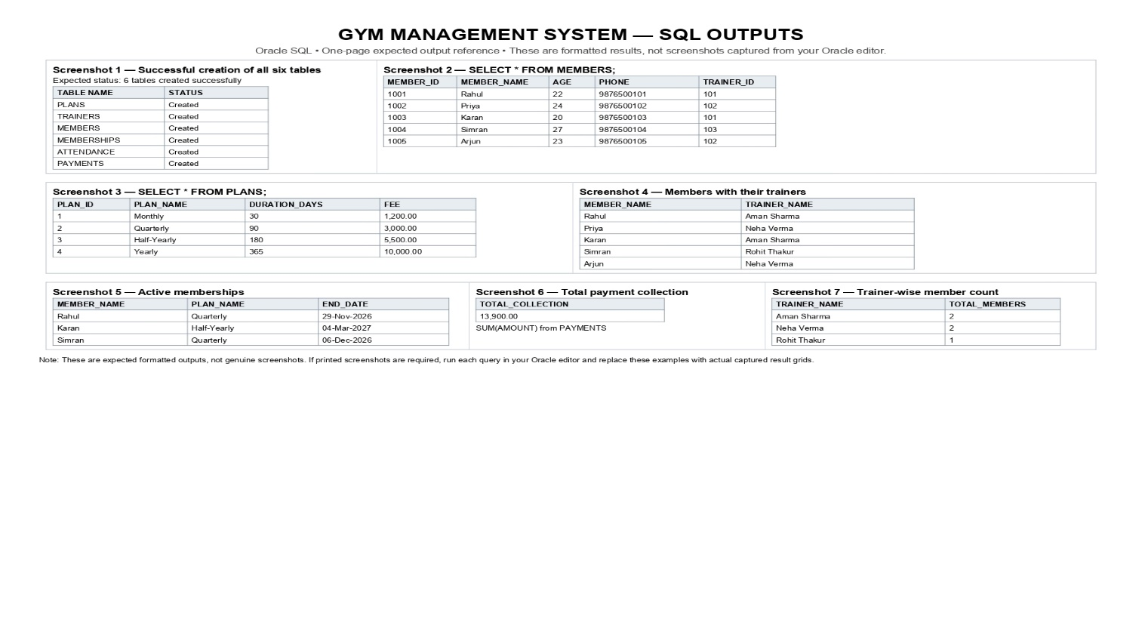

Github:-

5. Conclusion:-
The Gym Management System demonstrates the practical use of a relational database through Oracle SQL. It provides an organised way to manage gym members, trainers, membership plans, attendance records, and payments.
The project uses six related tables and demonstrates primary keys, foreign keys, data insertion, joins, and aggregate functions. These features help retrieve information efficiently and reduce the difficulties associated with manual record-keeping.
Through this project, I learned how to create database tables, establish relationships between tables, insert sample records, and execute SQL queries to generate useful reports. In the future, the system could be enhanced by adding a graphical user interface, login functionality, and automated membership-expiry notifications.

